Let’s Understand What is a job in a hadoop ecosystem:
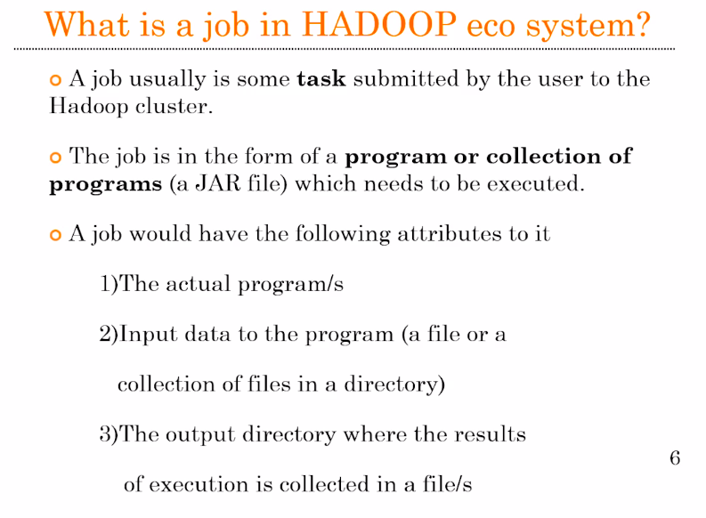
So, when you think of a complex job in a data science, it might involve a set of programs or a single program, which is trying to fetch the data from the hard drive and process it and then you will store the results back into the hard-drive in a file format.

In the Hadoop ecosystem, when we say a job, it’s a collection of programs or single program which is going to run in the cluster and the input data for that particular program is already going be residing in the hard-drive of the data node. So, this data is coming from the distributed file system of hadoop, which is called as HDFS. A typicall job of a hadoop system is consist of a set of programs in the form of JAR file, because the entire Hadoop environment is programmed in Java. Along with the Jar file we have to specify the input file path and the output file path.

